**INTI International College Penang School of Engineering and Technology**

**3+0 Bachelor of Science (Hons) in Computer Science, in collaboration with Coventry University, UK**

**3+0 Bachelor of Science (Hons) in Computing, in collaboration with Coventry University, UK**

**Coursework cover sheet**

**Section A - To be completed by the student**

|  |  |
| --- | --- |
| Full Name: Ko Chi Ling | |
| CU Student ID Number: 13446950  INTI Student ID Number: P21013435 | |
| Semester:1 | |
| Session:  **August 2022** | |
| Lecturer:  **Nadhrah Abdul Hadi (nadhrah.abdulhadi@newinti.edu.my)** | |
| Module Code and Title:  **4067CEM Software Design** | |
| Assignment No. / Title:  **Continuous Assessment** | % of Module Mark:  **50** |
| Hand out Date:  **6th September 2022** | Due Date:  **Task 1: 30 September 2022, by 11.59pm.**  **Task 2: 18 November 2022, by 11.59pm**  **Task 3: 4 November 2022, by 11.59pm.**  **Task 4: 4 November 2022, by 11.59pm.**  **Task 5: 4 November 2022, by 11.59pm.** |
| Penalties: No late work will be accepted. If you are unable to submit coursework on time due to extenuating circumstances, you may be eligible for an extension. Please consult the lecturer. | |
| Declaration: I/we the undersigned confirm that I/we have read and agree to abide by the University regulations on plagiarism and cheating and Faculty coursework policies and procedures. I/we confirm that this piece of work is my/our own. I/we consent to appropriate storage of our work for plagiarism checking.  Signature(s): ________________________ | |

**Section B - To be completed by the module leader**

|  |  |  |
| --- | --- | --- |
| Intended learning outcomes assessed by this work:  1. Understand and apply appropriate concepts, tools and techniques to each stage of the software development  2. Understand and apply design patterns to software components in developing new software  3. Demonstrate an understanding of project planning and working to agreed deadlines, along with professional, interpersonal skills and effective communication required for software production  5. Demonstrate an awareness of, and ability to apply, social, professional, legal and ethical standards as documented in relevant laws and professional codes of conduct such as that of the Malaysian National Computer Confederation. | | |
| Marking scheme | Max | Mark |
| 1. User Story Mapping 2. Setting up a GitHub Repository 3. Creating a Class diagram and design pattern selection 4. Creating a Prototype User Interface and Usability Testing 5. Discuss the ethical issue related to the software | 20  10  30  20  20 |  |
| Total | 100 |  |

Task 4

**Usability Testing Question**

**Overall Prototype:**

1. What is your rating for the buddy system prototype user interface?
2. Does this buddy system prototype is easy to be used?
3. What do you think about the design for this prototype?
4. Would you use this buddy system app frequently?
5. Do you need a technical support while using this app?
6. Do you think you need to learn a lot before you using this buddy system app?
7. How would you describe your overall experience with this interface design?
8. What features in the buddy system app do you find most valuable and why?
9. What feature do you want to add in to this buddy system interface design?
10. What features do you think need to be improved in this prototype?

**My Buddy:**

1. What is your rating for the My Buddy prototype user interface?
2. Does this My Buddy prototype is easy to be used?
3. What features in the My Buddy do you find most valuable and why?
4. What feature do you want to add in to this My Buddy interface design?
5. What features do you think need to be improved in this prototype?

**Study Forum:**

1. What is your rating for the study forum prototype user interface?
2. Does this study forum prototype is easy to be used?
3. What features in the study forum do you find most valuable and why?
4. What feature do you want to add in to this study forum interface design?
5. What features do you think need to be improved in this prototype?

**Two main functions in the buddy system app**

**My Buddy:**

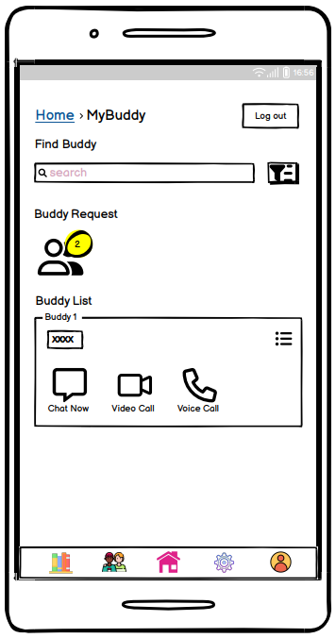 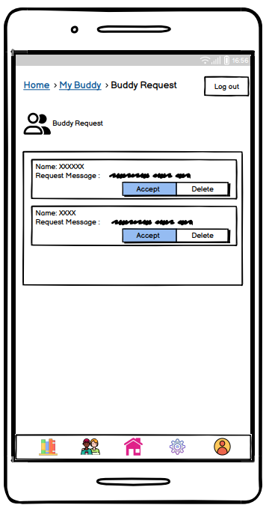 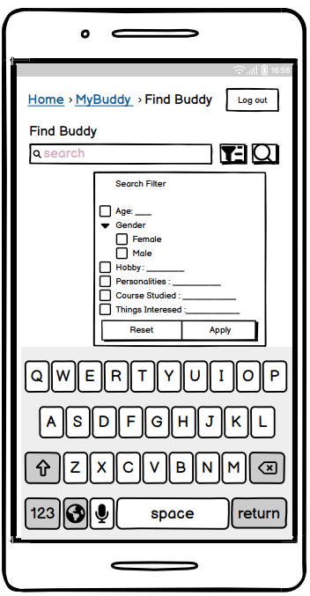

My Buddy Buddy Request Find Buddy

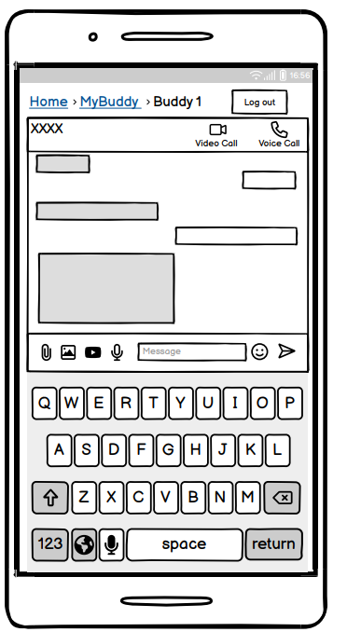  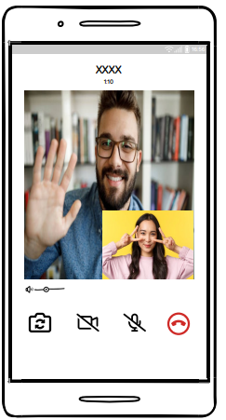 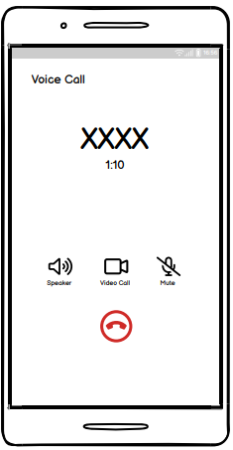

Chat function Video Call Voice Call

**Figure 1 : Feature Inside My Buddy**

My Buddy is the main function of this app. My Buddy is chosen as a main function because the main objective of this buddy system has been made is to let the student to make friend that can exchange the studies tips and improve on the academics . This My Buddy function can let the user to find the buddies that suits them in the My Buddy function. The user can also chat with the buddies to discuss the homework. The user can also video call or voice call the buddies to have better discussion on the academic.

My Buddy supports the function that is find buddy by searching keyword or applying filter. The user could see the list of the searched buddies. The user can add message to the buddies before send the request is send to the buddies. Then, the user must wait the buddy to accept the request, so that they are buddies. The user could also accept the buddy request when someone send request to the user. The user can also delete the request if the user do not want to add the buddy as friends. The user could also view the buddies list below the buddy request. The user can contact the buddies by message them, voice call them or video call them. The user can send voice message and also typing message. The user could share image, video and file for the buddies. The user could call their buddies by using voice call. The user can also change the voice call to video call by clicking the camera icons. The user could mute when the call is ongoing. The user can end the call by clicking the end call button. The user could also unfriend the buddy by sending request to the buddy and wait for the buddy to approve. After the unfriend buddy request is approved by the buddy, the buddy list will remove the buddy. If the user would like to add back the buddy, the user would need to send request again. The user can see the buddy’s profile by clicking the buddy’s username.

**Study Forum:**

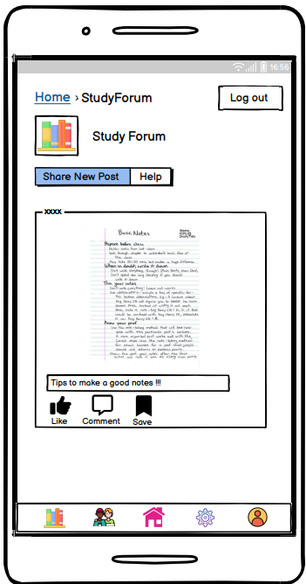 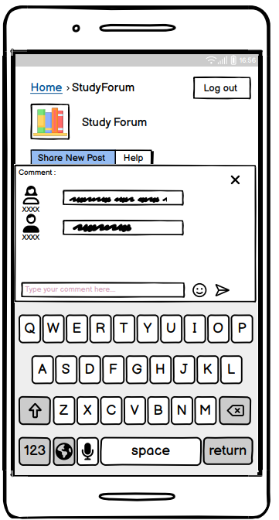 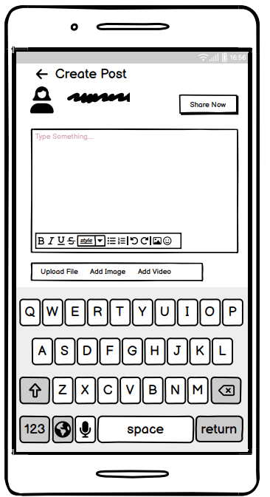

Study Forum Comment Create Post

**Figure 2 : Features Inside Study Forum**

Study Forum is also the main function in this app. Study forum is a place that could share the post to all the buddies in the buddy system app. The user could share the problems that are facing in the studies and let others to give some advice or help to solve the problems. Other users in study forum can view and comment on the post to help the user to solve the problems that faced on the academics. Study forum has been chosen as a main function in this buddy system app is because study forum can let the user to share the tips on studies to others. The users can save the post that other buddies share to improve the academic result.

The user can like the post. The user could comment the post. The user could also save the post that the user is interested in. The user could also publish their own post by clicking the share new post. Then, the user will come to create post page. The user could add image, add video, add file and write caption for the post. The user could discard the post if the user does not want to share the post. The user could also click share now button if they done editing the post. The user could also view others buddy profile by clicking the username of the post.

User Test Link:

<https://balsamiq.cloud/ssvdiho/pxnwvy1/r2278?f=N4IgUiBcAMA0IDkpxAYWfAMhkAhHAsjgFo4DSUA2gLoC%2BQA%3D>

Reviews Link:

<https://balsamiq.cloud/ssvdiho/pxnwvy1/r2278?f=N4IgUiBcCMA0IDkpxAYWfAMhkAhHAsjgFo4DSUA2gLoC%2BQA%3D>